Experiments in Machine Learning

Applications in Healthcare
[Year]
Contents
Cleveland Clinic Heart Disease Dataset 2
About Dataset 2
Content 3
Acknowledgements 3
KNIME Workflow 4
Autism Screening Dataset 5
About Dataset 5
Attribute Information: 6
Prostate Cancer Predictions 8
Last amended: 24th May, 2024 8
Kaggle reference 8
Context 8
About data 8
Maternal Health Risk Data 10
Predicting health risks for pregnant patients 10
Last amended: 24th May, 2024 10
Kaggle reference 10
About Dataset 10
Acknowledgements 10
Inspiration 10
Heart Failure Prediction - Clinical Records 12
Context: 12
Attribute Information: 12
Citation: 12

Cleveland Clinic Heart Disease Dataset
Predicting Coronary Heart Disease by Non-Invasive Means
# Last amended: 24th May, 2024
# Kaggle Reference
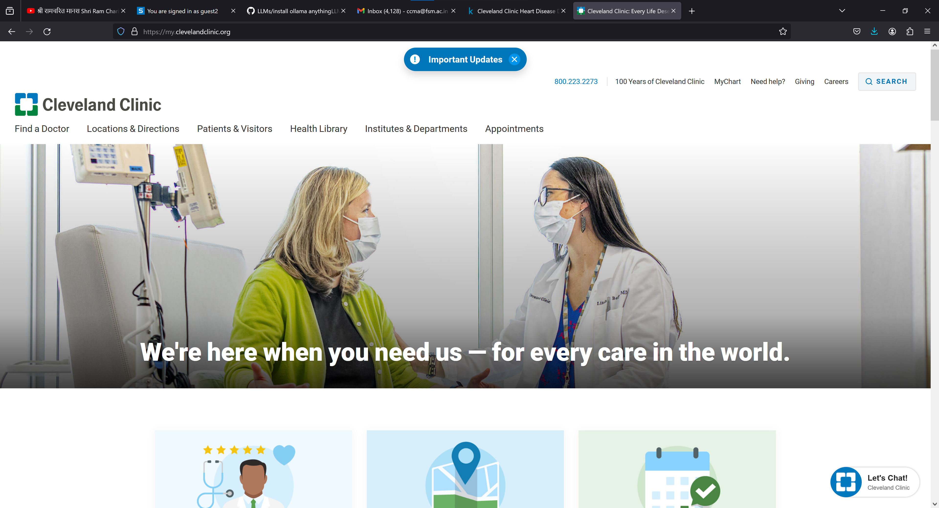

About Dataset
Coronary heart disease (CHD) involves the reduction of blood flow to the heart muscle due to build-up of plaque in the arteries of the heart. It is the most common form of cardiovascular disease. Currently, invasive coronary angiography represents the gold standard for establishing the presence, location, and severity of CAD, however this diagnostic method is costly and associated with morbidity and mortality in CAD patients. Therefore, it would be beneficial to develop a non-invasive alternative to replace the current gold standard.
Other less invasive diagnostics methods have been proposed in the scientific literature including exercise electrocardiogram, thallium scintigraphy and fluoroscopy of coronary calcification. However the diagnostic accuracy of these tests only ranges between 35%-75%. Therefore, it would be beneficial to develop a computer aided diagnostic tool that could utilize the combined results of these non-invasive tests in conjunction with other patient attributes to boost the diagnostic power of these non-invasive methods with the aim ultimately replacing the current invasive gold standard.
In this vein (pun intended), the following dataset comprises 303 observations, 13 features and 1 target attribute. The 13 features include the results of the aforementioned non-invasive diagnostic tests along with other relevant patient information. The target variable includes the result of the invasive coronary angiogram which represents the presence or absence of coronary artery disease in the patient with 0 representing absence of CHD and labels 1-4 representing presence of CHD. Most research using this dataset have concentrated on simply attempting to distinguish presence (values 1,2,3,4) from absence (value
0).
The data was collected by Robert Detrano, M.D., Ph.D of the Cleveland Clinic Foundation. See here for protocol specifics.
Also, this paper provides a good summary of the dataset context.

Content
The data set was downloaded from the UCI website.
Attribute Information:
- age: age in years
- sex: sex (1 = male; 0 = female)
- cp: chest pain type
  - Value 1: typical angina
  - Value 2: atypical angina
  - Value 3: non-anginal pain
  - Value 4: asymptomatic
- trestbps: resting blood pressure (in mm Hg on admission to the
hospital)
- chol: serum cholestoral in mg/dl
- fbs: fasting blood sugar > 120 mg/dl (1 = true; 0 = false)
- restecg: resting electrocardiographic results
  - Value 0: normal
  - Value 1: having ST-T wave abnormality (T wave inversions and/or ST elevation or depression of > 0.05 mV)
  - Value 2: showing probable or definite left ventricular hypertrophy by Estes' criteria
- thalach: maximum heart rate achieved
- exang: exercise induced angina (1 = yes; 0 = no)
- oldpeak: ST depression induced by exercise relative to rest
- slope: the slope of the peak exercise ST segment
  - Value 1: upsloping
  - Value 2: flat
  - Value 3: downsloping
- ca: number of major vessels (0-3) colored by flourosopy (for calcification of vessels)
- thal: results of nuclear stress test (3 = normal; 6 = fixed defect; 7 = reversable defect)
- num: target variable representing diagnosis of heart disease (angiographic disease status) in any major vessel
  - Value 0: < 50% diameter narrowing
  - Value 1: > 50% diameter narrowing

Acknowledgements
Robert Detrano, M.D., Ph.D: Principle investigator responsible for collecting data
Inspiration
Diagnosis of Coronary Heart Disease by non-invasive means.

KNIME Workflow

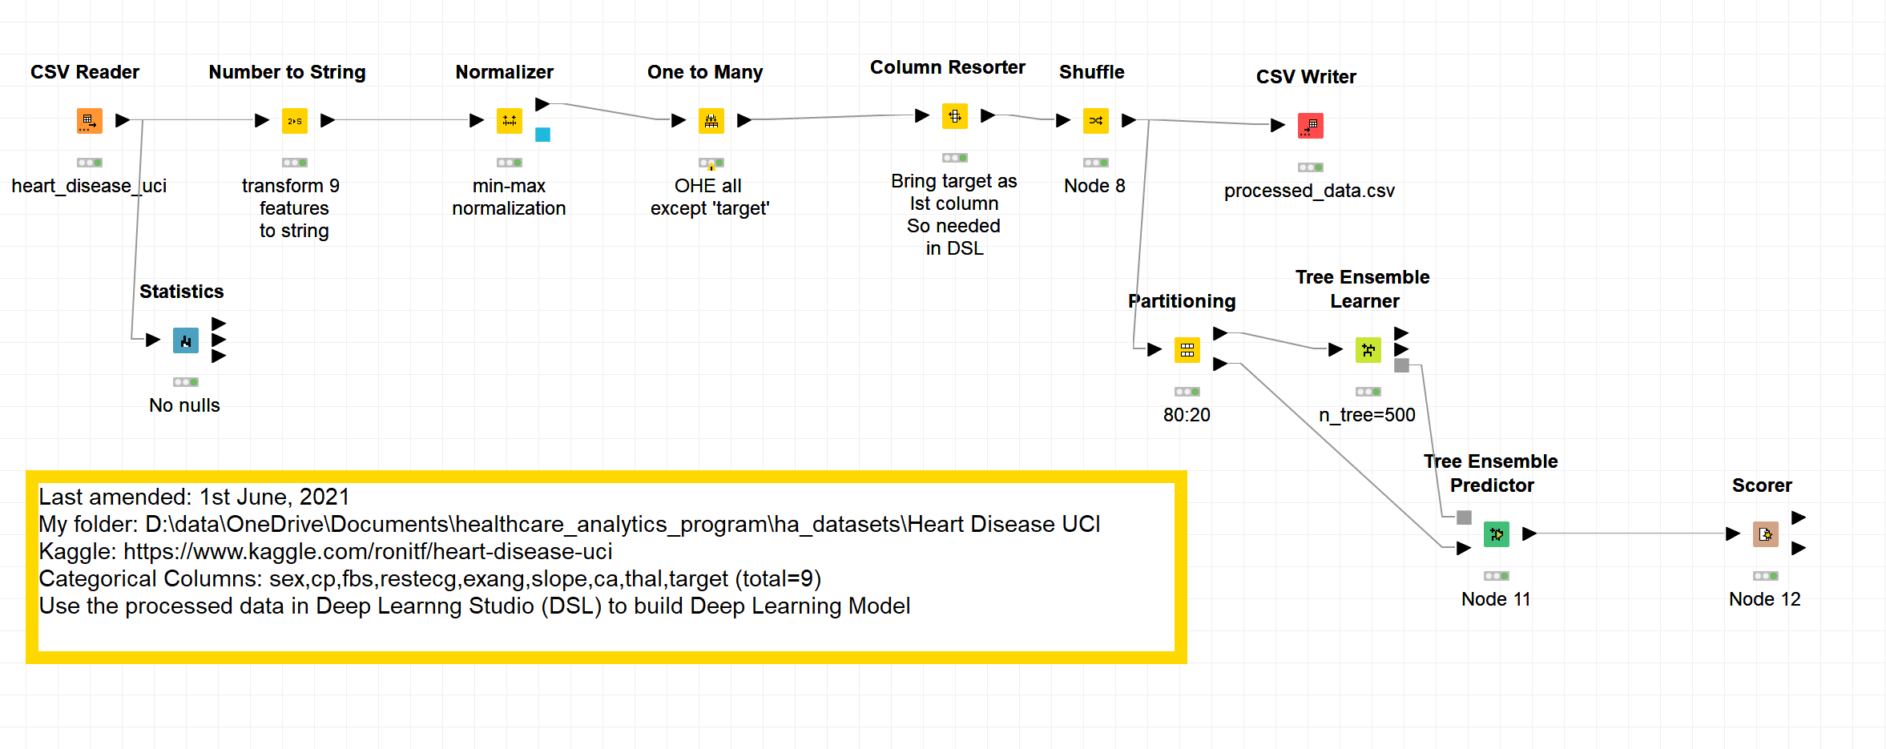

Autism Screening Dataset
# Last amended: 24th May, 2024
# Kaggle Reference



About Dataset
Autistic Spectrum Disorder (ASD) is a neurodevelopment condition associated with significant healthcare costs, and early diagnosis can significantly reduce these. Unfortunately, waiting times for an ASD diagnosis are lengthy and procedures are not cost effective. The economic impact of autism and the increase in the number of ASD cases across the world reveals an urgent need for the development of easily implemented and effective screening methods. Therefore, a time-efficient and accessible ASD screening is imminent to help health professionals and inform individuals whether they should pursue formal clinical diagnosis. The rapid growth in the number of ASD cases worldwide necessitates datasets related to behaviour traits. However, such datasets are rare making it difficult to perform thorough analyses to improve the efficiency, sensitivity, specificity and predictive accuracy of the ASD screening process. Presently, very limited autism datasets associated with clinical or screening are available and most of them are genetic in nature. Hence, we propose a new dataset related to autism screening of adults that contained 20 features to be utilised for further analysis especially in determining influential autistic traits and improving the classification of ASD cases. In this dataset, we record ten behavioural features (AQ-10-Adult) plus ten individuals characteristics that have proved to be effective in detecting the ASD cases from controls in behaviour science.

Attribute Information:
Age Number Age in years
Gender String Male or Female
Ethnicity String List of common ethnicities in text format
Born with jaundice Boolean (yes or no) Whether the case was born with jaundice
Family member with PDD Boolean (yes or no) Whether any immediate family member has a PDD
Who is completing the test String Parent, self, caregiver, medical staff, clinician ,etc.
Country of residence String List of countries in text format
Used the screening app before Boolean (yes or no) Whether the user has used a screening app
Screening Method Type Integer (0,1,2,3) The type of screening methods chosen based on age category (0=toddler, 1=child, 2= adolescent, 3= adult)
Question 1 Answer Binary (0, 1) The answer code of the question based on the screening method used
Question 2 Answer Binary (0, 1) The answer code of the question based on the screening method used
Question 3 Answer Binary (0, 1) The answer code of the question based on the screening method used
Question 4 Answer Binary (0, 1) The answer code of the question based on the screening method used
Question 5 Answer Binary (0, 1) The answer code of the question based on the screening method used
Question 6 Answer Binary (0, 1) The answer code of the question based on the screening method used
Question 7 Answer Binary (0, 1) The answer code of the question based on the screening method used
Question 8 Answer Binary (0, 1) The answer code of the question based on the screening method used
Question 9 Answer Binary (0, 1) The answer code of the question based on the screening method used
Question 10 Answer Binary (0, 1) The answer code of the question based on the screening method used
Screening Score Integer The final score obtained based on the scoring algorithm of the screening method used. This was computed in an automated manner.

KNIME Workflow:
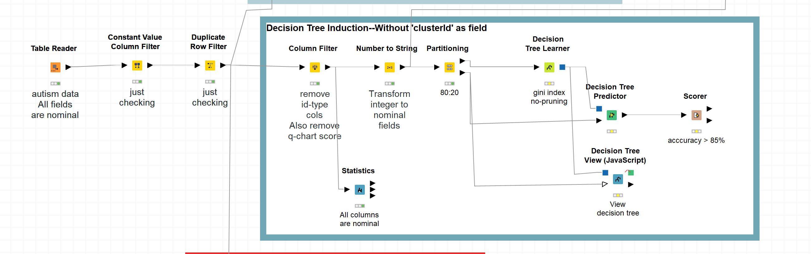

Prostate Cancer Predictions

Last amended: 24th May, 2024

Kaggle reference

Context
Prostate cancer is one of the most common forms of cancer among men, with an estimated 1 in 9 men being diagnosed with the disease during their lifetime. Early detection and treatment of prostate cancer is critical for improving patient outcomes and survival. However, current methods for diagnosing prostate cancer can be limited in their accuracy and may not always detect the disease in its early stages. The use of machine learning algorithms in medical research has become increasingly common in recent years, and these algorithms have shown promise in improving the accuracy of disease diagnosis.

About data
This is the dataset of 100 patients to implement the machine learning algorithm and thereby interpreting results.
The data set consists of 100 observations and 10 variables (out of which 8 numeric variables and one categorical variable and is ID) which are as follows:
- Id
1.Radius
2.Texture
3.Perimeter
4.Area
5.Smoothness
6.Compactness
7.diagnosis_result
8.Symmetry
9.Fractal dimension

KNIME Workflow:
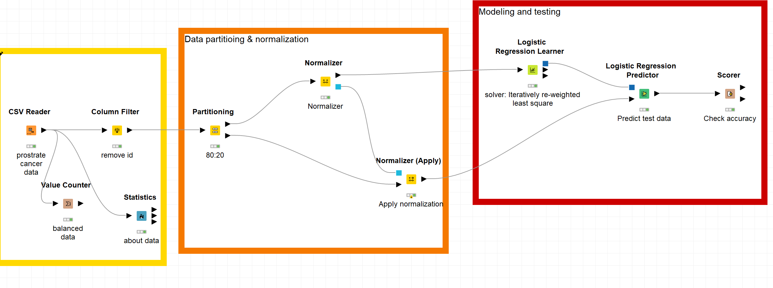

Maternal Health Risk Data

Predicting health risks for pregnant patients

Last amended: 24th May, 2024

Kaggle reference



About Dataset
Data has been collected from different hospitals, community clinics, maternal health cares through the IoT based risk monitoring system.
- Age: Age in years when a woman is pregnant.
- SystolicBP: Upper value of Blood Pressure in mmHg, another significant attribute during pregnancy.
- DiastolicBP: Lower value of Blood Pressure in mmHg, another significant attribute during pregnancy.
- BS: Blood glucose levels is in terms of a molar concentration, mmol/L.
- HeartRate: A normal resting heart rate in beats per minute.
- Risk Level: Predicted Risk Intensity Level during pregnancy considering the previous attribute.

Acknowledgements
Relevant Papers:
- Ahmed M., Kashem M.A., Rahman M., Khatun S. (2020) Review and Analysis of Risk Factor of Maternal Health in Remote Area Using the Internet of Things (IoT). In: Kasruddin Nasir A. et al. (eds) InECCE2019. Lecture Notes in Electrical Engineering, vol 632. Springer, Singapore. [Web Link]
- IoT based Risk Level Prediction Model for Maternal Health Care in the Context of Bangladesh, STI-2020, [under publication in IEEE]

Inspiration
Which health conditions are the strongest indications for health risks during pregnancy?

KNIME Workflow:
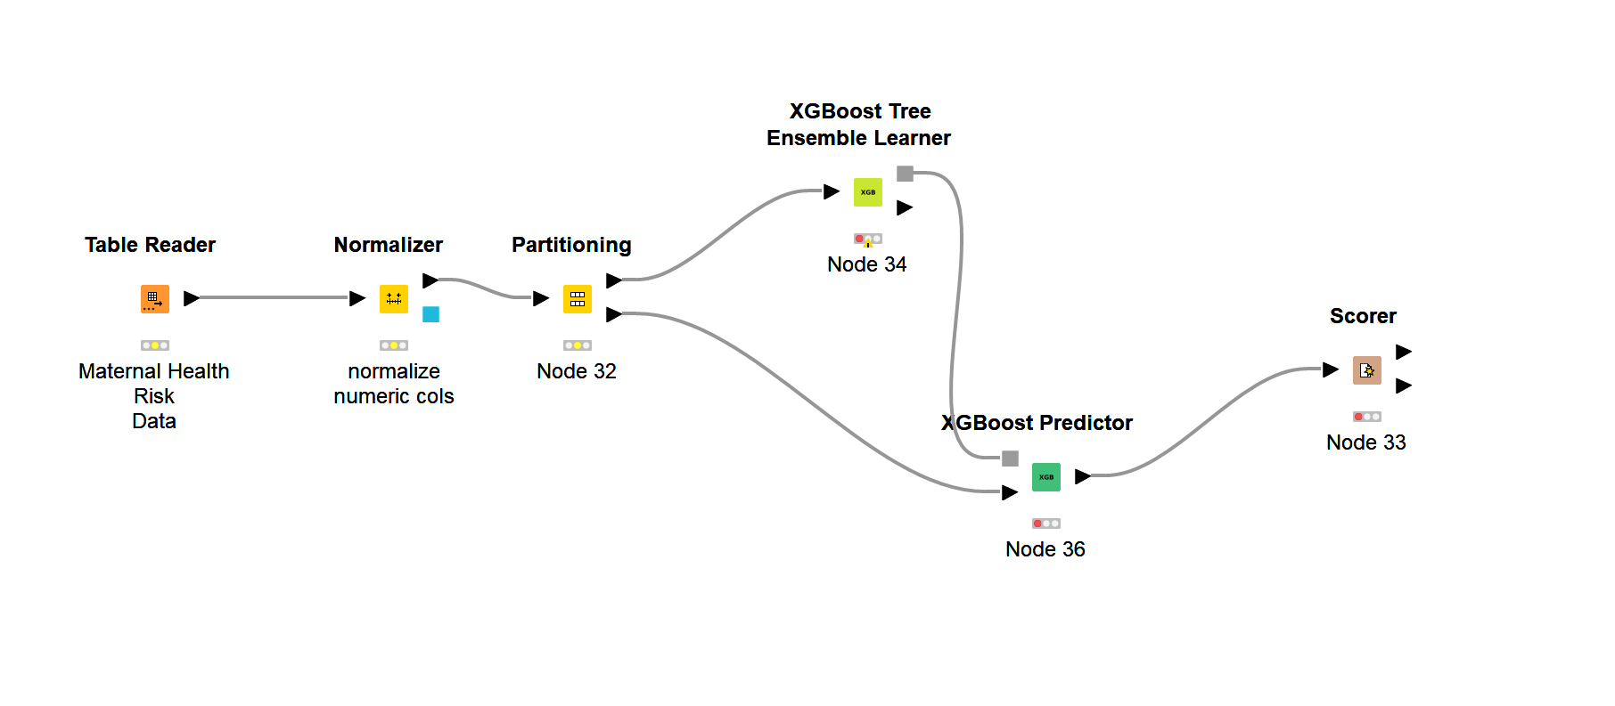

Heart Failure Prediction - Clinical Records
Last amended: 24th May, 2024
Kaggle reference



Context:
This dataset contains the medical records of 5000 patients who had heart failure, collected during their follow-up period, where each patient profile has 13 clinical features.

Attribute Information:
- age: age of the patient (years)
- anaemia: decrease of red blood cells or hemoglobin (boolean)
- creatinine phosphokinase (CPK): level of the CPK enzyme in the blood (mcg/L)
- diabetes: if the patient has diabetes (boolean)
- ejection fraction: percentage of blood leaving the heart at each contraction (percentage)
- high blood pressure: if the patient has hypertension (boolean)
- platelets: platelets in the blood (kiloplatelets/mL)
- sex: woman or man (binary)
- serum creatinine: level of serum creatinine in the blood (mg/dL)
- serum sodium: level of serum sodium in the blood (mEq/L)
- smoking: if the patient smokes or not (boolean)
- time: follow-up period (days)
- DEATH_EVENT: if the patient died during the follow-up period (boolean)

Citation:
Heart Failure Clinical Records. (2020). UCI Machine Learning Repository. https://doi.org/10.24432/C5Z89R.

******************

